13 December 2016
Bat species composition and activity in varying tree densities on Observatory Mesa, Flagstaff, Arizona
CLARISSA A. STARBUCK, School of Forestry, 200 E. Pine Knoll Dr., Northern Arizona University, Flagstaff, AZ 86011, USA
INTRODUCTION
As ecological restoration occurs in the southwest United States, it is important to monitor the effects of the restoration on wildlife species that use these areas for habitat. Bats are an important group of animals that provide many ecosystem services, such as eating insects that are crop pests (Boyles et al. 2011, Kunz et al. 2011). Many species of bats use ponderosa pine (Pinus ponderosa) forests in northern Arizona as places to forage for food and roost (Morrell et al. 1999, Rabe et al. 1998). How does ecological restoration of these forests near Flagstaff affect the bat activity and species activity in those forests?
I hypothesize that there will be more bat activity in the forests with lower tree densities than forests with high tree densities. Rancourt et al. (2007) suggested restoration of ponderosa pine forests in Washington State would benefit big brown bat maternity colonies, because they chose to roost in trees that were large (> 30 cm) in diameter, and the roosts were found more in open pine forests than closed pine forests. In northern Arizona, Rabe et al. (1998) found that the roosts of 8 different bat species were generally in large diameter ponderosa pine snags with exfoliating bark. I hypothesize that different bat species will use restored and non-restored forests differently. Species with lower frequency calls (< 30 kHz) will have higher activity in restored forest, whereas species with very high frequency calls (> 30 kHz) will have higher activity in non-restored forest since lower frequency sounds can travel farther than higher frequency sounds (Griffin 1971).
STUDY AREA
This study takes place on Observatory Mesa, Flagstaff, Arizona, USA. This area is part of the Flagstaff Watershed Protection Project (FWPP). The goal of the FWPP is to reduce the density of trees in areas near Flagstaff and reduce the risk of a severe wildfire (www.flagstaffwatershedprotection.org). Tree densities in the forested area before treatment ranged from 90 to 339 trees per acre (Arizona State Forestry Division, Flagstaff District Office 2015). Section 18 was thinned in 2015, parts of section 12 was thinned earlier in 2016, and section 8 has not been treated so far (Arizona State Forestry Division, Flagstaff District Office 2015). Sections 18 and 12 were treated with differing prescriptions within the section. The western part of section 12 is an open grassland that was burned by a wildfire in 1951 (Arizona State Forestry Division, Flagstaff District Office 2015). All forested areas are made up of mostly ponderosa pine trees and some gambel oak (Quercus gambelii), and understory grass species consist of Arizona fescue (Festuca arizonica), pine dropseed (Blepharoneuron tricholepis), mountain muhly (Muhlenbergia montana), and Kentucky bluegrass (Poa pratensis) (Arizona State Forestry Division, Flagstaff District Office 2015).
METHODS
I deployed 6 SongMeter3BAT (Wildlife Acoustics, Maynard, MA) acoustic devices from October 2, 2016 to October 12, 2016 in restored and non-restored forests representing a range of tree densities near Flagstaff (Figure 1). The microphones were placed on a pole so that they were 3 m above the ground. The poles were supported by three guy wires that were staked in to the ground with tent stakes, having minimal impacts to the site. Each device recorded the high frequency echolocation calls made by bats and downloaded the call files to an SD card. The devices were set to record from half an hour before sunset to half an hour after sunrise each night for 10 nights. After 10 nights, I collected all SD cards from the acoustic devices and downloaded the call files to a computer. Two devices stopped recording after 8 nights, so I only analyzed calls for all devices for 8 nights total. All call files were run through the computer program SonoBat version 3.2.1 US West (SonoBat, Arcata, CA). Using SonoBat, I got rid of all call files that were not bat sounds and identified the call files to species or species group using the automated classifier. I calculated total bat activity by calculating the number of call files over the 8 nights for each device. I calculated different species or species group activity by calculating the call files per device for each species or species group. Detected species were classified as having low (< 35 kHz) or high (> 35 kHz) frequency echolocation calls.
I calculated tree density for each site by using the pre-treatment trees per acre that was measured by Arizona State Forestry crews in January 2015 (Arizona State Forestry Division, Flagstaff District Office 2015), and then I subtracted the percent reduction in tree density designated by the Observatory Mesa Forest Stewardship Plan (Arizona State Forestry Division, Flagstaff District Office 2015), and I also used cutting prescription plans given to me by Matt Millar (Matt Millar, Flagstaff Fire Dept. Wildland Fire Management Division, personal communication). I used linear regression in the program R to determine if there are relationships between total bat activity or species activity and tree density.
RESULTS
SonoBat identified 9 species: big brown bat (Eptesicus fuscus), silver-haired bat (Lasionycteris noctivagans), Mexican free-tailed bat (Tadarida brasiliensis), hoary bat (Lasiurus cinereus), western small-footed bat (Myotis ciliolabrum), little brown bat (M. lucifugus), western long-eared bat (M. evotis), fringed myotis (M. thysanodes), and canyon bat (Parastrellus hesperus). Since western small-footed bat, little brown bat, and western long-eared bat were all high frequency calls (> 35 kHz) and were hard to distinguish, I placed these species in the “high frequency” group. Big brown bat, silver-haired bat, Mexican free-tailed bat, hoary bat, and fringed myotis were all included in the “low frequency” group. However, these calls can be more distinguishable, so I further broke these calls down in to species groups. Big brown bat and silver-haired bat can have indistinguishable calls and are similar in body size so these species were in the “Epfu/Lano” group. Mexican free-tailed bat and hoary bat can have indistinguishable calls and are similar in body size, so these species were in the “Tabr/Laci” group. Fringed myotis is distinguishable so all calls classified as fringed myotis were assumed to be that species and were classified as “Myth”. Only one bat call was classified as canyon bat, so I left this species out of analysis.
I calculated tree densities to range between 0 – 204 trees/acre. I collected 1,961 calls that were identified as a bat call by SonoBat. I collected 262 high frequency calls, 1,699 low frequency calls, 20 Epfu/Lano calls, 208 Tabr/Laci calls, and 425 Myth calls. I found no significant (i.e. p < 0.05) relationships between any species group and tree density. However, there was a slight negative trend for the relationship between tree density and total calls (p = 0.07224), low frequency (p = 0.0904), Myth (p = 0.1016), and Tabr/Laci (p = 0.419). Over half (53%) of all the bat calls were recorded at the open grassland site (Figure 2). Of those calls, 99% were low frequency calls (Figure 3). Ninety-one percent of the high frequency bat calls were recorded at tree densities between 70 – 130 trees/acre. Of the low frequency species, Myth had the highest number of calls, of which most (71%) were in the open grassland (Figure 4). The Tabr/Laci group had the most number of calls (28.8%) at the site with 115 trees/acre, followed closely by the open grassland (26.4% of calls) (Figure 4). The greatest activity by the Epfu/Lano group (30% of calls) was at the site with 204 trees/acre, followed equally by the grassland site and the site with 155 trees/acre (20% of calls each) (Figure 4).
Sites that were treated more than a year ago (in 2015) had a slightly higher number of total bat calls and higher low and high frequency bat calls than sites that were treated earlier this year (in 2016) (Figure 5).
DISCUSSION
Several studies in the eastern United States have shown that forests that have been managed by thinning or prescribed fire that results in lower tree densities have higher bat occupancy or bat activity for some bat species than forests with no management and higher tree densities (Armitage and Ober 2012, Ford et al. 2006, Loeb and O’Keefe 2006, Loeb and Waldrop 2008, Starbuck 2015, Yates and Muzika 2006). This study had similar results however I expected more bat calls in more forested areas than I collected. I predicted that bats with lower frequency echolocation calls and longer, narrower wings would have more calls in areas that were less tree density. Within the forest, I did not find a significant relationship, but I did find that there was a much higher number of calls in the open grassland. This open grassland provides a good place to forage, especially for bats with long, narrow wings. These bats probably roost in the nearby forest, then forage in the open grassland. I predicted that bats with higher frequency calls and short, broad wings would have more calls in forests with higher densities. I did not find this to be true in this study. Although no high frequency calls were detected in the open grassland, most high frequency calls were detected in forests with low to moderate tree densities. These species most likely roost in the trees nearby, and although these species are more maneuverable than species with long, narrow wings, they might still prefer to forage in areas with less clutter.
Fringed myotis was the most detected species, especially in the open grassland. Although this species has a low frequency echolocation call compared to other Myotis species, this species is known to forage in and around trees (Western Bat Working Group 2005), which contradicts the findings of this study. This study was conducted in mid-autumn, when the temperatures started to drop, and not much is known about the winter behavior or possible migration of the fringed myotis. Most of the calls were recorded the first and warmest night of the study. This species could have been moving from a summer/fall roost to a winter roost in preparation for the colder weather.
Mexican free-tailed bats and hoary bats had the highest activity in the open grassland, which is consistent with previous studies and their morphology. These species are known to be mostly migratory. The lower numbers of calls from this species group could be because most of these individuals have migrated to lower elevations or other parts of the country since this study was conducted just after these species would normally move out of the area (Villa and Cockrum 1962, Cryan 2003). The low numbers of big brown bat and silver-haired bat calls could also be due to the cold temperatures and possible migratory behavior of these species (Cryan 2003, Neubaum et al. 2006).
The higher number of bat calls in the sites that were restored more than a year ago in 2015 versus the sites that were recently treated in 2016 could show that over time, more bats will use areas that have been restored. The amount of noise and traffic that was going on during the treatment could have caused some bats to move away from those areas. Those sites also had less understory vegetation, such as grasses and forbes than the sites that had been treated over a year ago (personal observation). Less human traffic, as well as possible insects attracted by new grasses and forbes, probably influenced the increased calls at the sites that had been treated more than a year ago.
Restoration by removal of trees on Observatory Mesa, Flagstaff, Arizona does not seem to influence the local bat species activity currently. I think future work could be done to look at bat activity in different times of the year, at more individual sites across the mesa, and after more time has passed after restoration treatments.
LITERATURE CITED
Arizona State Forestry Division, Flagstaff District Office. 2015. Forestry Stewardship Plan: Observatory Mesa. City of Flagstaff, AZ, USA.
Armitage, D. W. and H. K. Ober. 2012. The effects of prescribed fire on bat communities in the longleaf pine sandhills ecosystem. Journal of Mammalogy 93: 102 – 114.
Boyles, J. G., P. M. Cryan, G. F. McCracken, and T. H. Kunz. 2011. Economic importance of bats in agriculture. Science 332: 42 – 42.
Cryan, P. M. 2003. Seasonal distribution of migratory tree bats (Lasiurus and Lasionycteris) in North America. Journal of Mammalogy 84: 579 – 593.
Ford, W. M., J. M. Menzel, M. A. Menzel, J. W. Edwards, and J. C. Kilgo. 2006. Presence and absence of bats across habitat scales in the upper Coastal Plain of South Carolina. Journal of Wildlife Management 70: 1200 – 1209.
Griffin, D. R. 1971. The importance of atmospheric attenuation for the echolocation of bats (Chiroptera). Animal Behavior 19:55 – 61.
Kunz, T. H., E. Braun de Torrez, D. Bauer, T. Lobova, and T. H. Fleming. 2011. Ecosystem services provided by bats. Annals of the New York Academy of Sciences 1223: 1 – 38.
Loeb, S. C. and J. M. O’Keefe. 2006. Habitat use by forest bats in South Carolina in relation to local, stand, and landscape characteristics. Journal of Wildlife Management 70: 1210 – 1218.
Loeb, S. C. and T. A. Waldrop. 2008. Bat activity in relation to fire and fire surrogate treatments in southern pine stands. Forest Ecology and Management 255: 3185 – 3192.
Morrell, T. E., M. J. Rabe, J. C. deVos, Jr., H. Green, and C. R. Miller. 1999. Bats captured in two ponderosa pine habitats in north-central Arizona. The Southwestern Naturalist 44: 501 – 506.
Neubaum, D. J., T. J. O’Shea, and K. R. Wilson. 2006. Autumn migration and selection of rock crevices as hibernacula by big brown bats in Colorado. Journal of Mammalogy 87: 470 – 479.
Rabe, M. J, T. E. Morrell, H. Green, J. C. deVos, Jr., and C. R. Miller. 1998. Characteristics of ponderosa pine snag roosts used by reproductive bats in northern Arizona. The Journal of Wildlife Management 62: 612 – 621.
Rancourt, S. J., M. I. Rule, and M. A. O’Connell. 2007. Maternity roost site selection of big brown bats in ponderosa pine forests of the Channeled Scablands of northeastern Washington State, USA. Forest Ecology and Management 248: 183 – 192.
Starbuck, C. A., S. K. Amelon, and F. R. Thompson. 2015. Relationships between bat occupancy and habitat and landscape structure along a savanna, woodland, forest gradient in the Missouri Ozarks. Wildlife Society Bulletin 39: 20 – 30.
Villa, B. and E. L. Cockrum. 1962. Migration in the guano bat Tadarida brasiliensis mexicana (Saussure). Journal of Mammalogy 43: 43 – 64.
Western Bat Working Group. 2005. Species accounts: Fringed myotis.
Yates, M. D. and R. M. Muzika. 2006. Effect of forest structure and fragmentation on site occupancy of bat species in Missouri Ozark forests. Journal of Wildlife Management 70: 1238 – 1248.

FIGURES
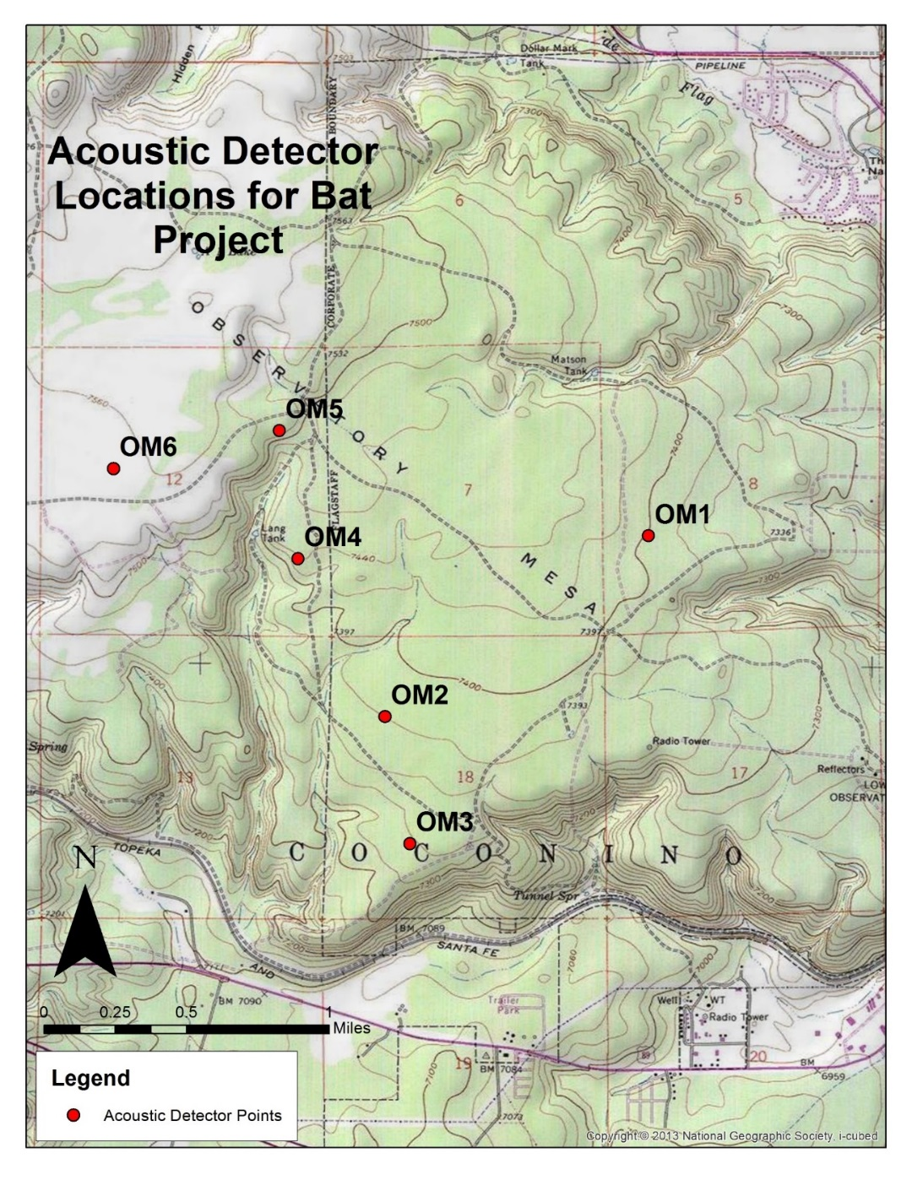
Figure 1. Location of sites on Observatory Mesa, Flagstaff, Arizona where acoustic bat detectors were deployed to sample for bat activity.
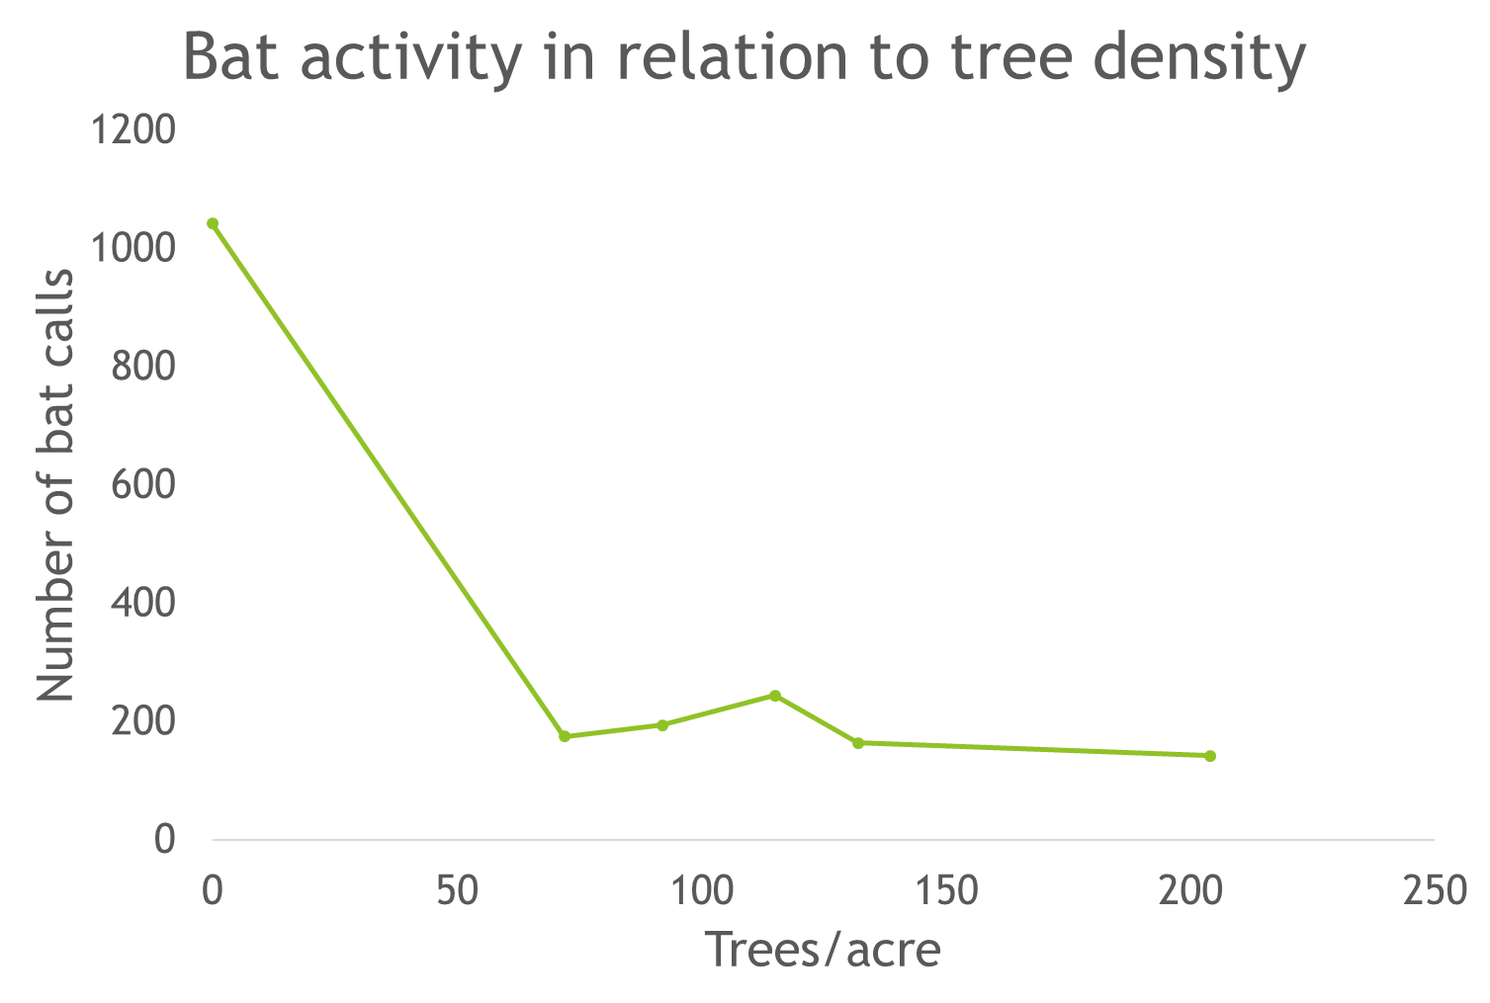
Figure 2. Bat activity (number of bat calls recorded) in relation to tree density (trees/acre).
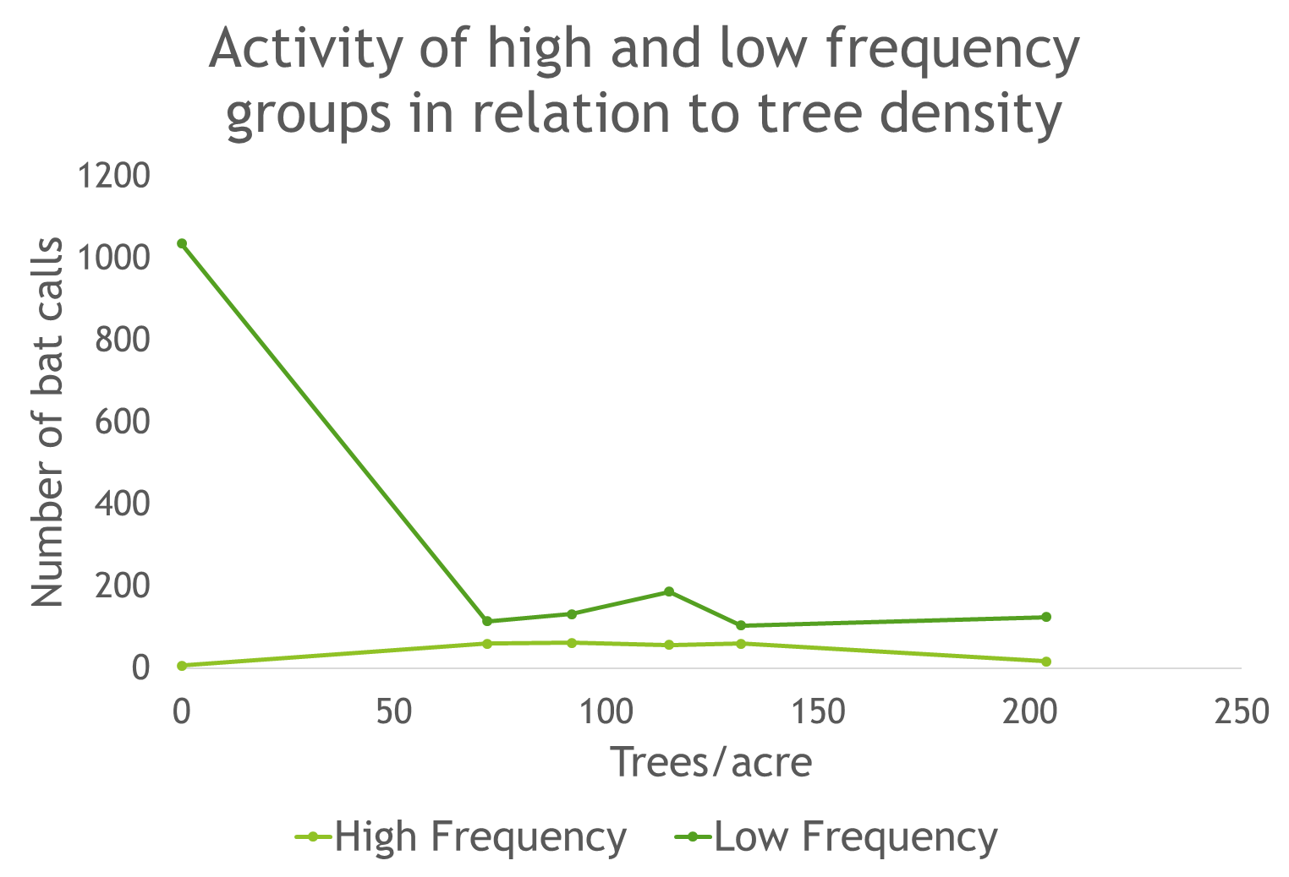
Figure 3. Bat activity (number of bat calls recorded) of high and low frequency call groups in relation to tree density (trees/acre).
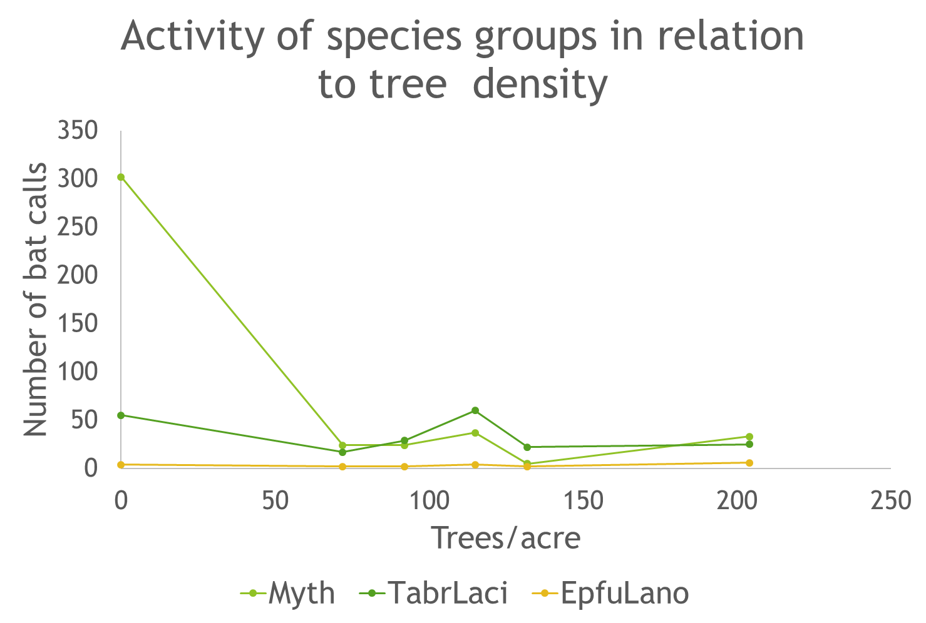
Figure 4. Bat activity (number of bat calls recorded) of the species groups Myth (Myotis thysanodes), Tabr/Laci (Tadarida brasiliensis and Lasiurus cinereus), and Epfu/Lano (Eptesicus fuscus) in relation to tree density (trees/acre).
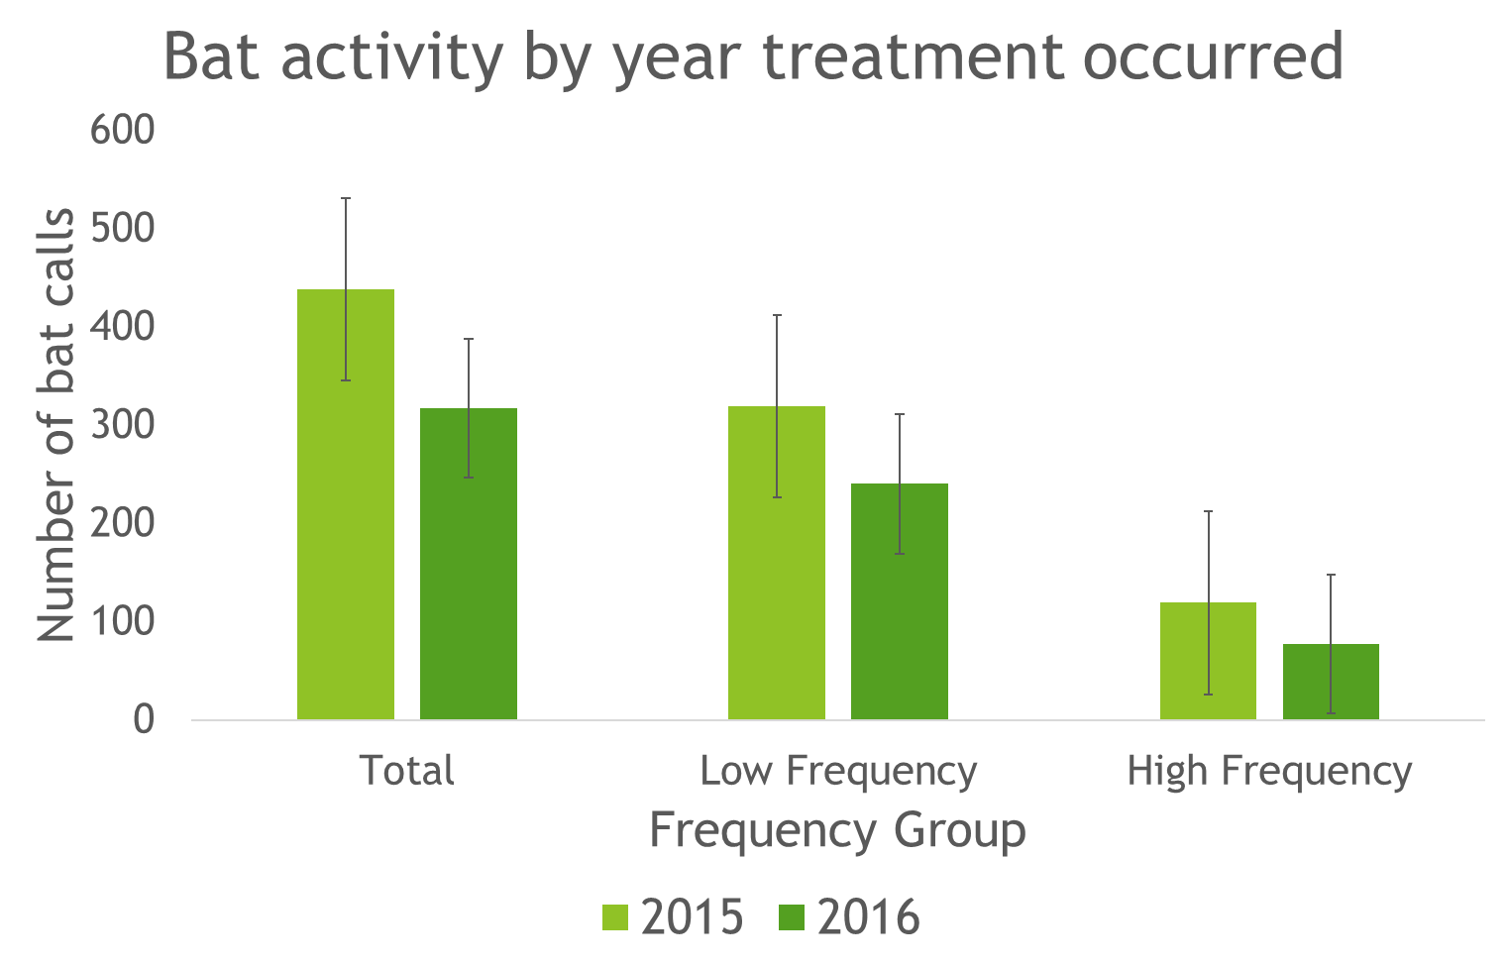
Figure 5. Bat activity (number of bat calls recorded) in relation to year of restoration treatment.

