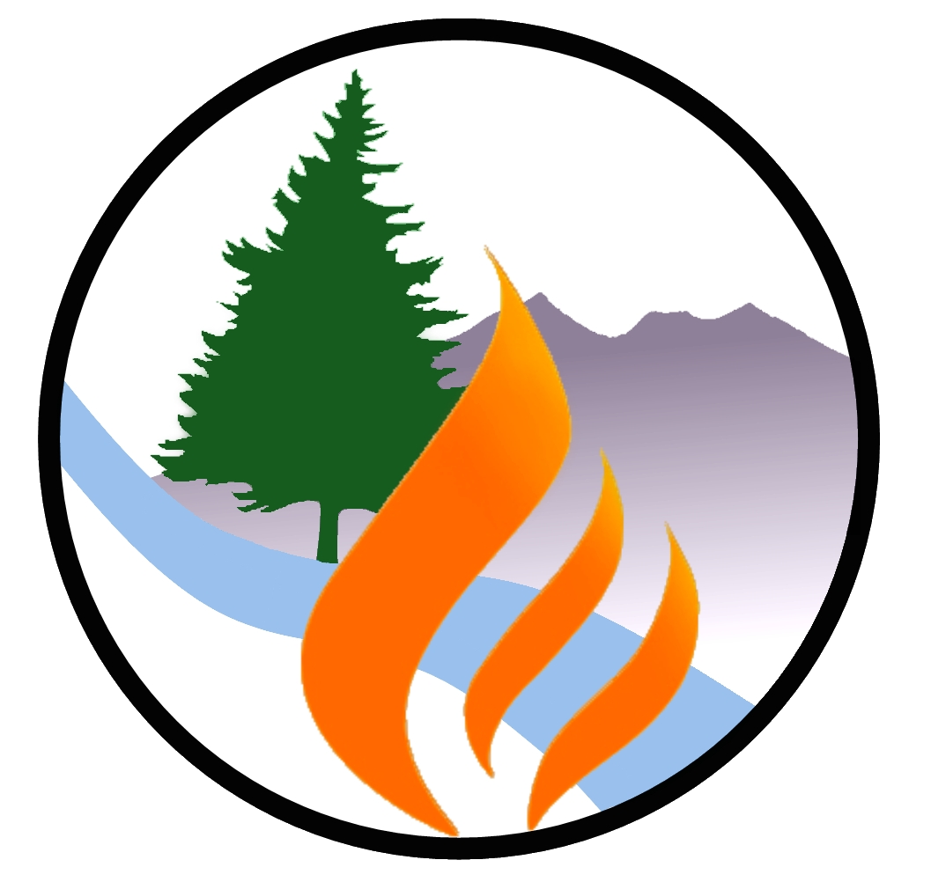
Flagstaff Watershed Protection Project
Alternative Recreation Trails
Summer 2019

The Flagstaff Watershed Protection Project is underway in the Dry Lake Hills area immediately north of town. Purpose is to reduce the risk of catastrophic wildfires impacting our community and our forest and the post-fire flooding that would follow. We appreciate your understanding and patience during the forest and trail closures while the work is being completed.
We encourage you to explore the links below to learn more about the full range of our communities’ trails and walking paths. There are a multitude of alternative recreational trails throughout the greater Flagstaff area that remain open for your enjoyment.
For more information on alternative recreation please visit the following web pages:

City of Flagstaff Open Space Program
https://www.flagstaff.az.gov/2194/Natural-Areas

City of Flagstaff Urban Trails System (FUTS)
https://www.flagstaff.az.gov/1379/Flagstaff-Urban-Trails-System-FUTS
Coconino County Trails
http://coconino.az.gov/282/Trails
Flagstaff Ranger District Trails
https://www.fs.usda.gov/detailfull/coconino/recreation/?cid=stelprdb5320237&width=full
Flagstaff Biking Organization, Mtn Bike Trails
https://flagstaffbiking.org/mountain/?

For the latest information on the Project itself: www.flagstaffwatershedprotection.org

